**MOVIE LANDING PAGE WEBSITE DESIGN**

|  |  |
| --- | --- |
| **NAME** | **: VATTIKUTI SRIMANTH** |
| **EMAIL** | **: vattikutisrimanth30@gmail.com** |
|  |  |
| **ROLL NO** | **: 20HU1A0449** |
|  |  |

**COLLEGE NAME: CHEBROLU ENGINEERING COLLEGE**

**PH NO: 9346147210**

**source code:**

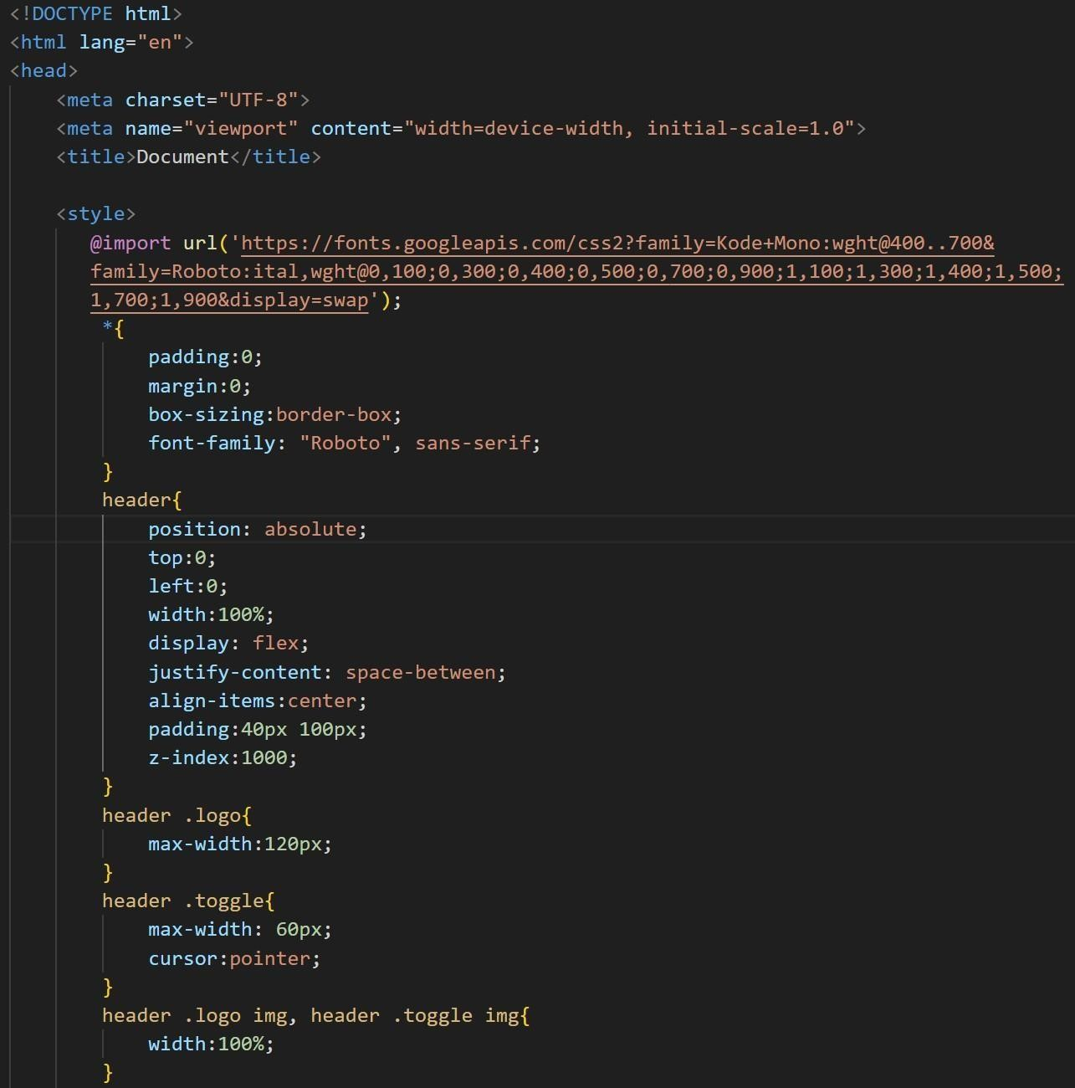

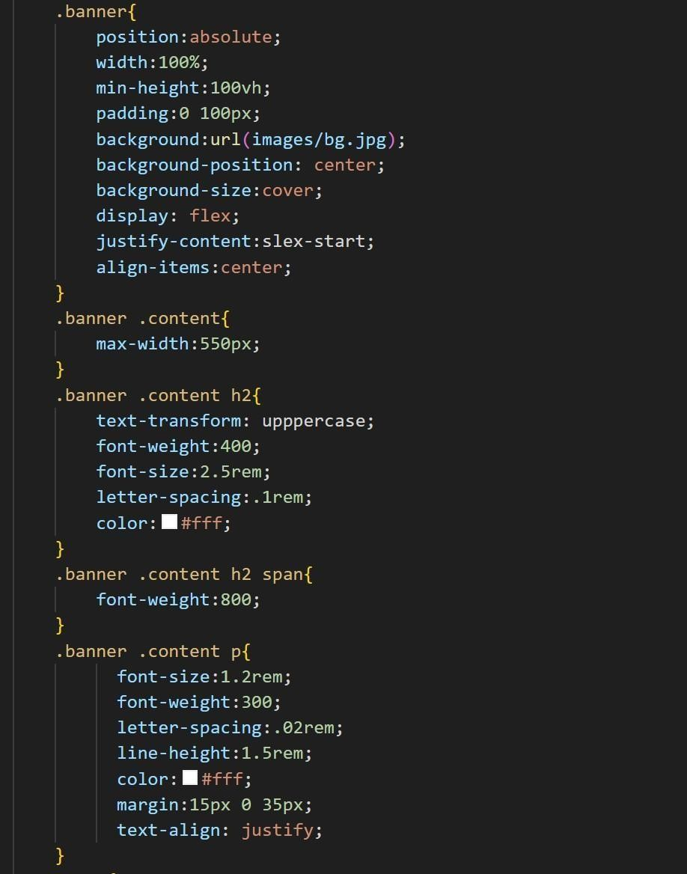

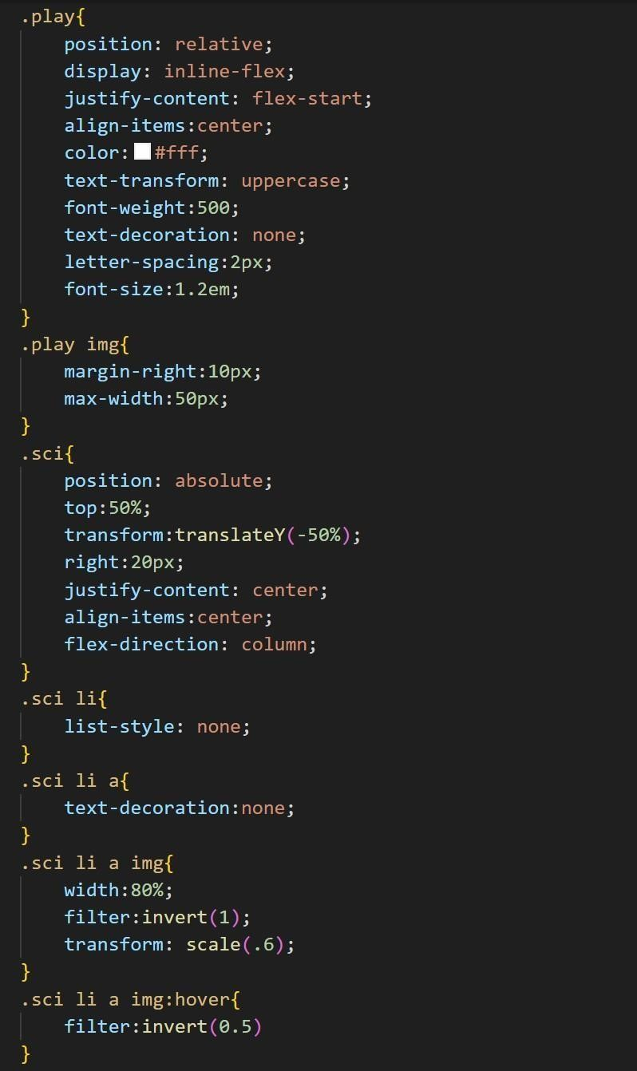

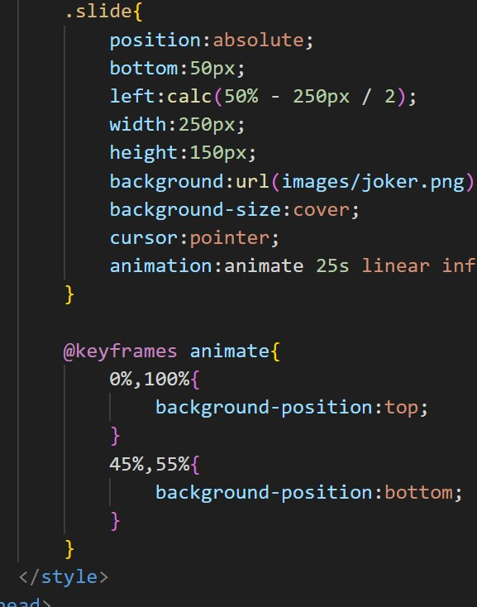

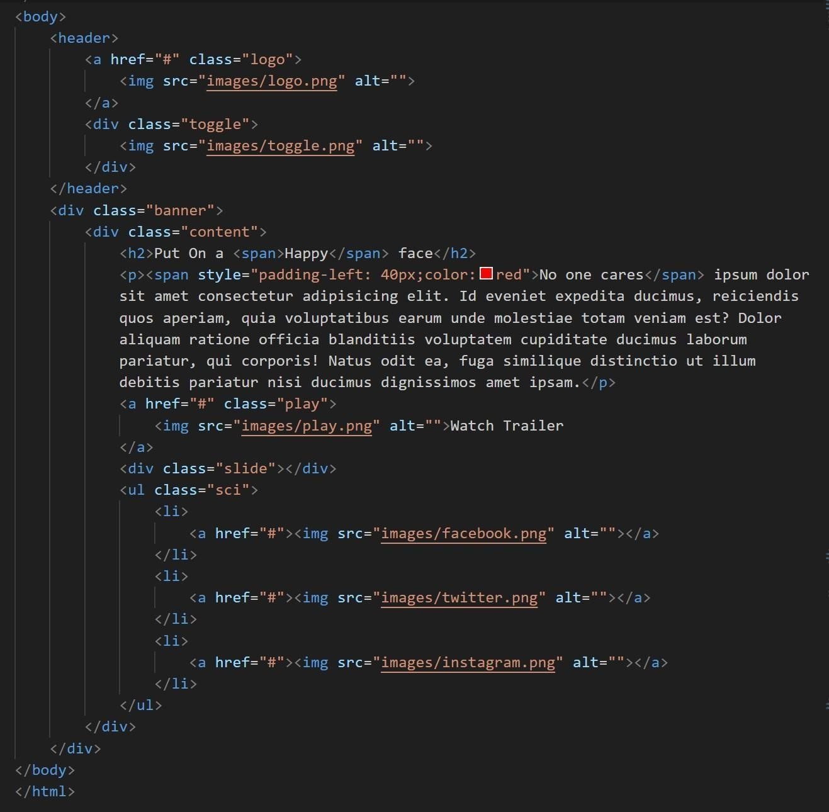

**flnal output :**

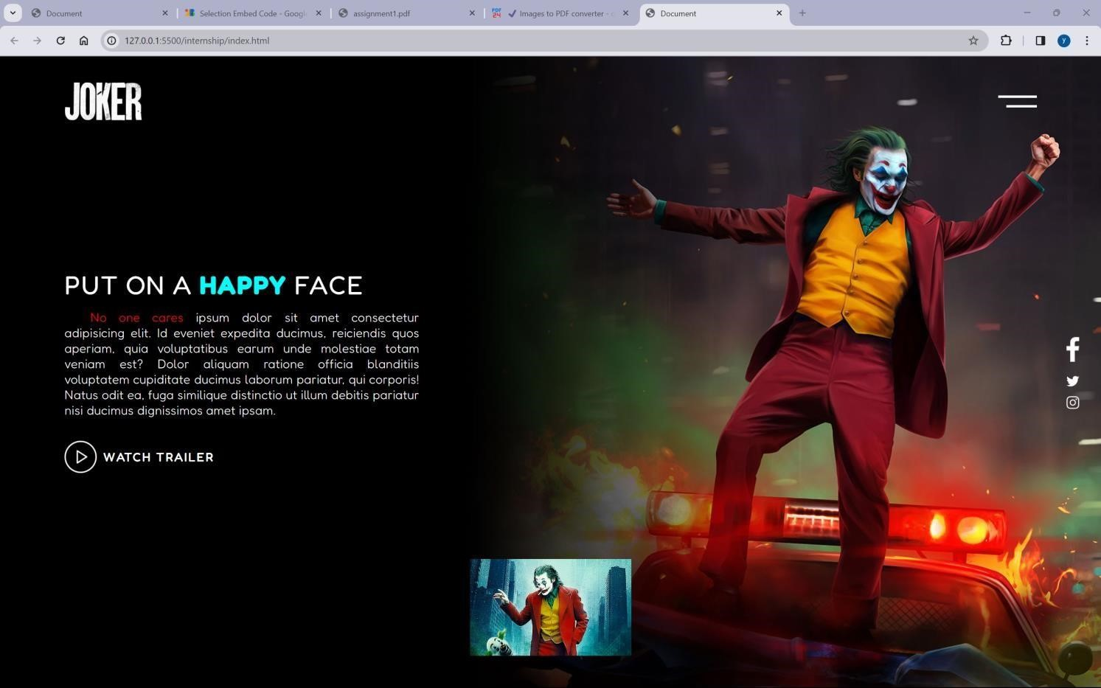

live demo : <https://4727yesuraju.github.io/static-webpage/>source code: <https://github.com/4727yesuraju/static-webpage>